BREAKFAST CHATTER
Weekly Bulletin of Rotary Club of Kathmandu Mid-Town
District 3290 Volume No. 15/18 for #760 November 19, 2004
www.rotarymidtown.org.np
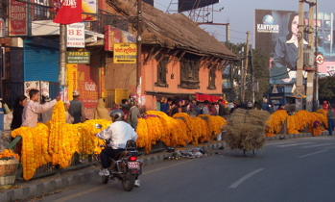
NOVEMBER IS ROTARY FOUNDATION MONTH

SUNSHINE ANNOUNCEMENT FOR THE WEEK OF 19 NOVEMBER 2004;
No marriages! No birthdays! At this rate we need to include children and grandchildren to get some action! Instead, here is a memory of an amazingly flowerful Laxmi Puja, 2004.
***********

MEETING ACTIVITIES:
DATE | ACTIVITY | SUBJECT
19 NOV | Jean Christoph Ryckmans | Chandrodaya—a real ray of hope
28 NOV | Dinner Meeting | Combo Charter Night & Taiwan Guests
3 DEC | Shyam Nepali | the best of Sarangi
10 DEC | Rabi Karmacharya | Software Outsourcing Prospects for Nepal
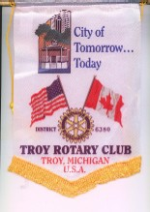
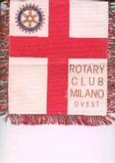
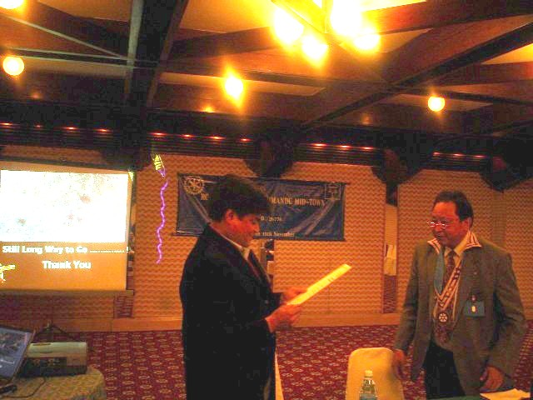
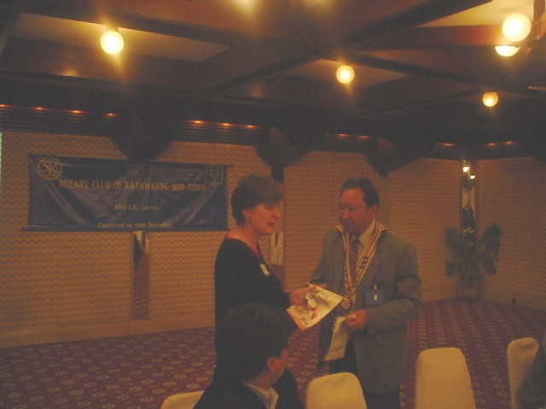
**************** NEWS: Five M-T Rotarians have brightened the future for the Bhaktapur Cancer Hospital: 100,000 thanks each to Ambika, Giri, Gobinda, Gopan and Mani! ***Add Troy Michigan and Milano flags to the M-T collection. *** Thanks also to Roshan Shrestha for a provocative reminder of the valley’s water crisis, and the actions we all can take to make the problem less severe. *** Next week on the 28th is a working medical camp at Tilganga. You can help!

Speaker Roshan Shrestha Rtn Eileen Heasley
**************** THIS WEEK’S PRESENTATION BY JEAN CHRISTOPH RYCKMANS

The Right To Dream. The Right To Be
“Street Children are social beings like everyone else. They are children, not small adults. We all share a responsibility to ensure that no child is left behind…”
**************** Please join us to hear Chandrodaya’s plans YIR…David

